Batch: B2 Roll No.: 1611103

Experiment / assignment / tutorial No. 2

Grade: AA / AB / BB / BC / CC / CD /DD

Signature of the Staff In-charge with date

TITLE: To study and implement Booth’s Multiplication Algorithm.

AIM: Booth’s Algorithm for Multiplication
______________________________________________________________________
Expected OUTCOME of Experiment:

CO 2-Detail working of the arithmetic logic unit and its sub modules
_____________________________________________________________________
Books/ Journals/ Websites referred:

- Carl Hamacher, Zvonko Vranesic and Safwat Zaky, “Computer Organization”, Fifth Edition, TataMcGraw-Hill.
- William Stallings, “Computer Organization and Architecture: Designing for Performance”, Eighth Edition, Pearson.
3. Dr. M. Usha, T. S. Srikanth, “Computer System Architecture and Organization”, First Edition, Wiley-India.
_____________________________________________________________________
Pre Lab/ Prior Concepts:

It is a powerful algorithm for signed number multiplication which generates a 2n bit product and treats both positive and negative numbers uniformly. Also the efficiency of the algorithm is good due to the fact that, block of 1’s and 0’s are skipped over and subtraction/addition is only done if pair contains 10 or 01

Flowchart:

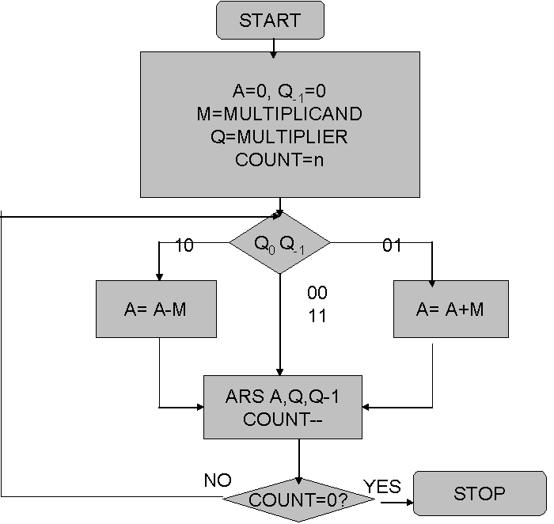

Design Steps:
#include<stdio.h>
#include<conio.h>
void bic(int l,int p[])
{
int i = 0;
while(l != 0)
{
p[i] = l%2;
i++;
if(i >= 16)
l = 0;
else
l = l/2;
}
for(;i<16;i++)
{
p[i] = 0;
}
}
void printb(int n[])
{
for(int i = 15;i>=0;i--)
{
printf("%d",n[i]);
}
printf("\t");
}
int check(int a,int b)
{
if((a+b == 2) ||(a+b == 0))
{
return 0;
}
else if(a == 0 && b ==1)
{
return 2;
}
else if(a==1 && b==0)
{
return 1;
}
else
return 3;
}
void add(int A[],int m[])
{
int carry = 0;
for(int i =0;i<16;i++)
{
A[i] = A[i] + m[i] + carry ;
carry = 0;
if(A[i] == 2)
{
A[i] = 0;
carry = 1;
}
else if(A[i] == 3)
{
A[i] = 1;
carry = 1;
}
else
continue;
}
}
void sub(int a[],int m[])
{
int n[16];
for(int j = 0;j<16;j++)
{
n[j] = m[j];
}
for(int i = 15;i>=0;i--)
{
if(n[i] == 0)
{
n[i] = 1;
continue;
}
else if(n[i] == 1)
{
n[i] = 0;
continue;
}
}
int m1[] = {1,0,0,0,0,0,0,0,0,0,0,0,0,0,0,0};
add(n,m1);
add(a,n);
}
void shift(int a[],int q[],int *q1)
{
int temp = a[0];*q1 = q[0];
for(int i = 0;i<15;i++)
{
a[i] = a[i+1];
q[i] = q[i+1];
}
q[15] = temp;
}
void main()
{
clrscr();
int M,Q,Q1 = 0,count = 16;
printf("Enter the multiplicant : ");
scanf("%d",&M);
printf("Enter the multiplier : ");
scanf("%d",&Q);
int m[16],q[16];
if( M < 0)
{
M = -M;
bic(M,m);
for(int i = 15;i>=0;i--)
{
if(m[i] == 0)
{
m[i] = 1;
continue;
}
else if(m[i] == 1)
{
m[i] = 0;
continue;
}
}
int m1[] = {1,0,0,0,0,0,0,0,0,0,0,0,0,0,0,0};
add(m,m1);
}
else
{bic(M,m);}
if( Q < 0)
{
Q = -Q;
bic(Q,q);
for(int i = 15;i>=0;i--)
{
if(q[i] == 0)
{
q[i] = 1;
continue;
}
else if(q[i] == 1)
{
q[i] = 0;
continue;
}
}
int m1[] = {1,0,0,0,0,0,0,0,0,0,0,0,0,0,0,0};
add(q,m1);
}
else
{bic(Q,q);}
//printb(m);
//printb(q);
int A[16];
for(int i = 0;i<16;i++)
{
A[i] = 0;
}
label:
switch(check(q[0],Q1))
{
case 2 :add(A,m);
//printf("step add: \n");
//printb(A);
break;
case 1 :sub(A,m);
//printf("step sub : \n");
//printb(A);
break;
case 3 :printf("error!:-(");
count = 0;
break;
case 0 :
default :break;
}
shift(A,q,&Q1);
//printf("step shift : \n");
//printb(A);
//printb(q);printf("%d\t",Q1);
count--;
if(count>0)
goto label;
else
{
printf("The multiplication of the given nos: \n");
printb(A);
printb(q);
}
getch();
}

Example:

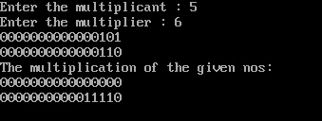

Conclusion:
Hence the program for Booth’s Multiplication was successfully studied and implemented.
Post Lab Descriptive Questions (Add questions from examination point view)

- Draw the Circuit diagram for booths algorithm.
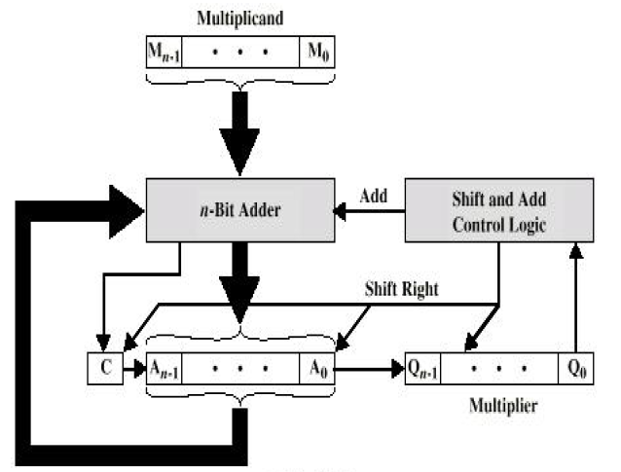
- Explain advantages and disadvantages of booth algorithm
The two main advantages of this algorithm are speed and the ability to do signed multiplication (using two's complement) without any extra conversions. In fact, the algorithm relies on two's complement.
The disadvantages are:
1. The number of add/subtract operations became variable and hence became inconvenient while designing Parallel multipliers.
2. The Algorithm becomes inefficient when there are isolated 1s

Date: Signature of faculty in-charge

